**AWS Cloudshell**

**Project Report 1-A**

**TE- COMPUTER ENGINEERING**

**By**

**Karishma Bairi A-15**

**Shweta Kaware A-06**

**Abhishek Eitkar A-14**

Under the Guidance of

**Prof. Smita Pai**



**Department of Computer Engineering TERNA ENGINEERING COLLEGE**

Nerul (W), Navi Mumbai 400706

(University of Mumbai)

(2021-2022)

**Internal Approval Sheet**



**TERNA ENGINEERING COLLEGE, NERUL**

**Department of Computer Engineering**

Academic Year 2021-22

**CERTIFICATE**

This is to certify that the project entitled “**AWS Cloudshell”** is a bonafide work of

**Karishma Bairi A-15**

**Shweta Kaware A-06**

**Abhishek Eitkar A-14**

**Guide Project Convener Head of Department Principal**

**Approval Sheet**

## Project Report Approval

This Project Report – Entitled “**AWS Cloudshell**” by following students is approved for the Mini Project-A of Third Year - Div A -COMPUTER ENGINEERING.

***Submitted by:***

**Karishma Bairi A-15**

**Shweta Kaware A-06**

**Abhishek Eitkar A-14**

Examiners Name & Signature:

1.---------------------------------------------------------

2.----------------------------------------------------------

Date: ---------------------------------

Place: ---------------------------------

**DECLARATION**

We hereby declare that the project entitled ‘AWS Cloudshell’ submitted by our team affirms that all the information and particulars furnished here by us are true and correct to the best of our knowledge. We further declare that we have cohered to principles of academic honesty and probity. Additionally, we have not misinterpreted or counterfeit any data/source in our contravention or violation of the above will gave use to punitive measures by the institute. We also confirm that the report is only prepared for our academic requirement and not for any other purpose.

|  |  |
| --- | --- |
| **Karishma Bairi** | **TU3F1920014 -------------------------** |
| **Shweta Kaware** | **TU3F1920005 --------------------------** |
| **Abhishek Eitkar** | **TU3F1920013 --------------------------** |

Date: _____________________

Place: _____________________

**ACKNOWLEDGEMENT**

Finest projects are always incomplete without the guidance and expertise of those who have mastered in their respective fields, so we would like to take this opportunity to express our gratitude towards all our experienced mentors who have helped us visualize their projects of ours. We express our deep gratitude and respect to our project guide **Prof. Smita Pai** for always been there with us right from the start as a pillar of strength when it came to guiding us. Hence, we appreciate for owing us his experience wisdom in his field.

We extend our sincere gratitude towards all the dedicated professor of - Terna Engineering College for enlighting us with their knowledge which they have garnered over the years.

We have indebted to our **HOD Mrs. Archana Mire** for extending her help directly and indirectly through various agencies. We take the privilege to express our gratitude towards **principal Dr. L.K** **Raga** for always encouraging and supporting us throughout our efforts.

|  |  |
| --- | --- |
| **Karishma Bairi** | **TU3F1920014 -------------------------** |
| **Shweta Kaware** | **TU3F1920005 -------------------------** |
| **Abhishek Eitkar** | **TU3F1920013 -------------------------** |

# **ABSTRACT**

AWS CloudShell is a browser-based shell that makes it easy to securely manage, explore, and interact with your AWS resources. CloudShell is pre-authenticated with your console credentials. Common development and operations tools are pre-installed, so no local installation or configuration is required. With CloudShell, you can quickly run scripts with the AWS Command Line Interface (AWS CLI), experiment with AWS service APIs using the AWS SDKs, or use a range of other tools to be productive. You can use CloudShell right from your browser and at no additional cost.

# **TABLE OF CONTENTS**

**ABSTRACT**

* **CHAPTER 1: INTRODUCTION**
* **CHAPTER 2: METHODOLOGY**
* **CHAPTER 3: RESULTS**
* **CHAPTER 4: CONCLUSION**

**REFERENCES**

# **CHAPTER 1: INTRODUCTION**

AWS CloudShell is a browser-based, pre-authenticated shell that you can launch directly from the AWS Management Console. You can run AWS CLI commands against AWS services using your preferred shell (Bash, PowerShell, or Z shell). And you can do this without needing to download or install command line tools.

When you launch AWS CloudShell, a compute environment that's based on Amazon Linux 2 is created. Within this environment, you've access to an extensive range of pre-installed development tools, options for uploading and downloading files, and file storage that persists between sessions.

A key benefit of AWS CloudShell is that you can use it to manage your AWS services from the command line interface. This means that you don't need to download and install tools or configure your credentials locally beforehand. When you launch AWS CloudShell, a compute environment is created that has the following AWS command line tools already installed:

* AWS CLI
* AWS Elastic Beanstalk CLI
* Amazon ECS CLI
* AWS SAM

# **CHAPTER 2: METHODOLOGY**

1. Step 1: Sign in to AWS Management Console.
2. Step 2: Launch AWS CloudShell, select a Region, and choose a shell.
3. Step 3: Upload a file to AWS CloudShell.
4. Step 4: Edit your file's code and run it from the command line.
5. Step 5: Use AWS CLI to add the file as an object in an Amazon S3 bucket.

**CHAPTER 3: RESULTS**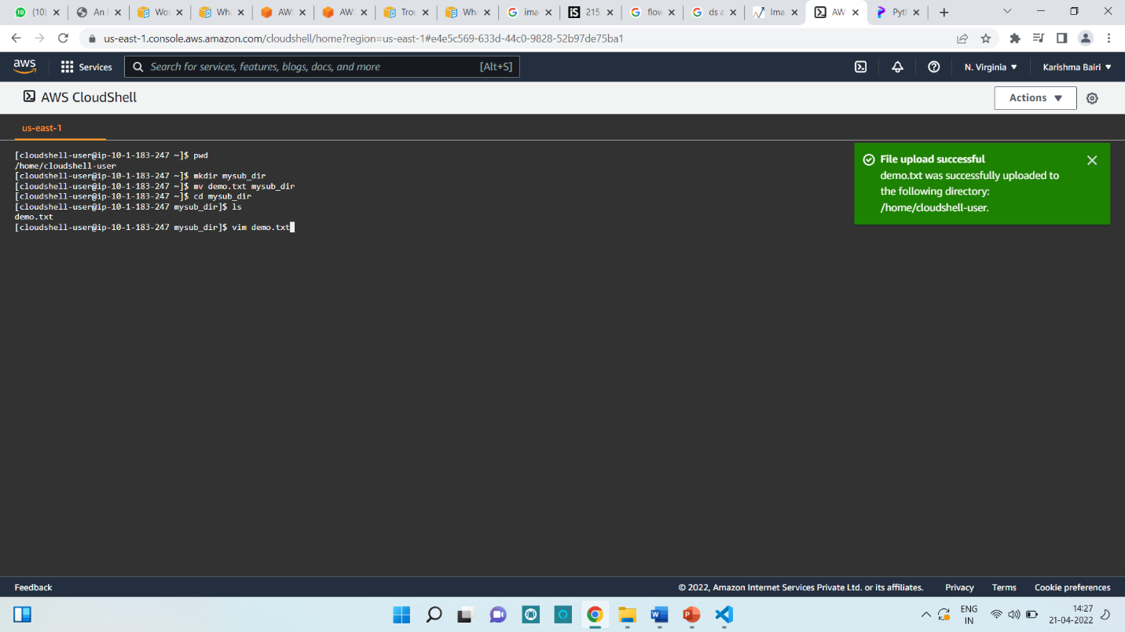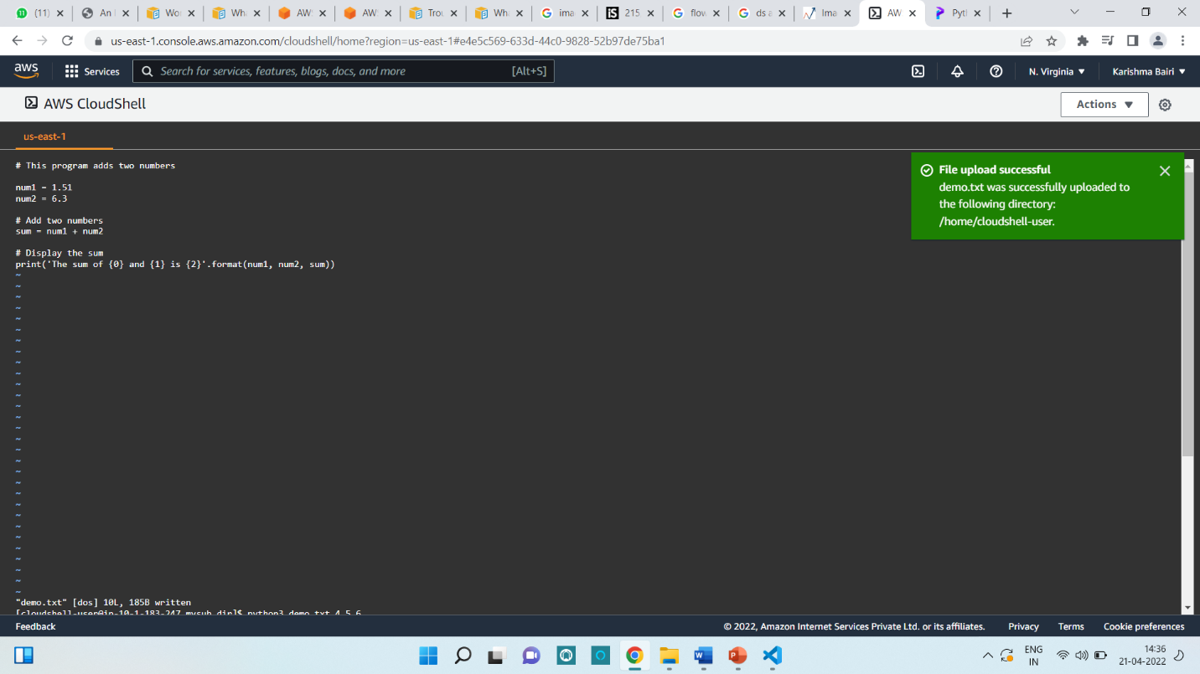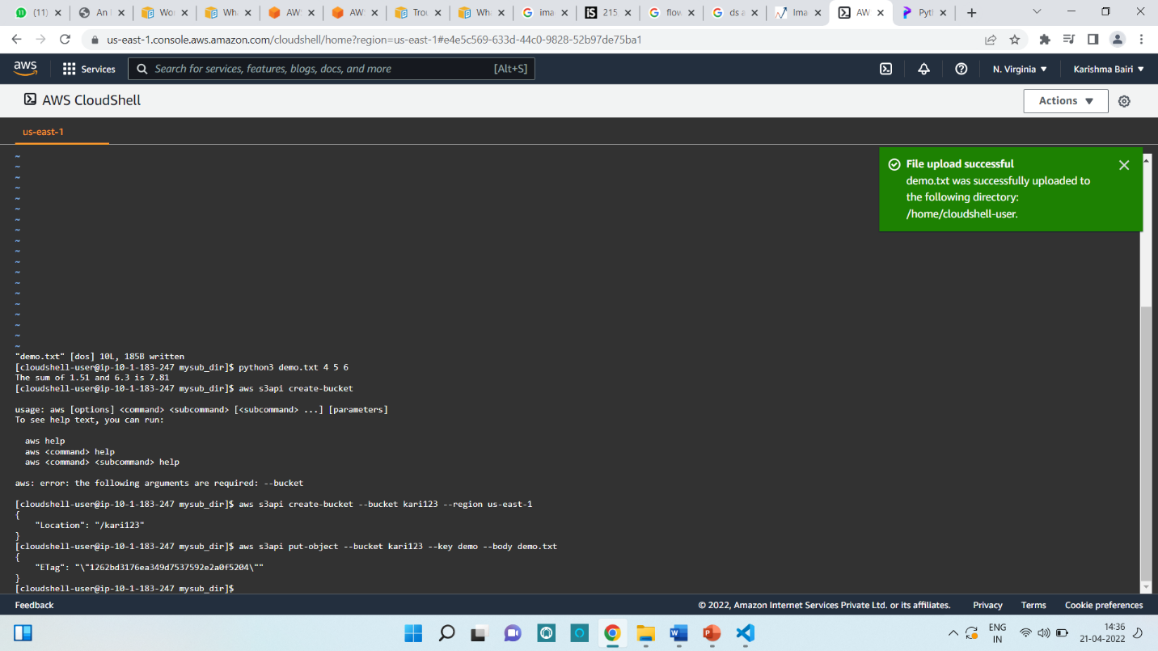

**CHAPTER 4: CONCLUSION**

* Amazon SES is a great tool for reducing your overall maintenance of the email service.
* It is quite cost-effective since you only have to pay for what you use.
* It also offers 12-month free trials for its first users so that they get engaged and understand how it works, and then as per business requirements.
* Apart from cost-effectiveness, SES is backed by Amazon Web Services, allowing you to integrate third-party plugins so that you don't have to rely only on Amazon.
* The AWS CloudShell is a useful service if you want a quick shell that is pre-configured to work with your AWS console credentials without having to generate IAM keys. This ensures that no keys are generated unnecessarily or leaked accidentally or otherwise, preventing security issues that can arise due to key or credential leakage.
* The CloudShell service is implemented as an ECS container that is running in an inaccessible AWS account but owing to the presence of an IMDSv2 service, session tokens are generated and used to access your AWS resources as the same user who logged into the AWS console. We can identify the AWS cluster that is running the ECS tasks using the Task Metadata endpoint.
* Overall, from a usability point of view, having a shell on the cloud with full AWS SDK capabilities, a functional package manager and outbound Internet access can lead to all sorts of interesting use cases, that we believe will be highlighted by peers in the community in the coming weeks and months.

**References**

* <https://docs.aws.amazon.com/cloudshell/latest/userguide/getting-started.html>
* <https://deliciousbrains.com/ses-vs-mailgun-vs-sendgrid/>
* <https://aws.amazon.com/cloudshell/>
* <https://cloud.google.com/shell>